CREATE DB2 AND CONNECT PYTHON

|  |  |
| --- | --- |
| Team ID | PNT2022TMID14860 |
| Project Name | Project -SMART FASHION RECOMMENDER |

CREATE IBM DB2

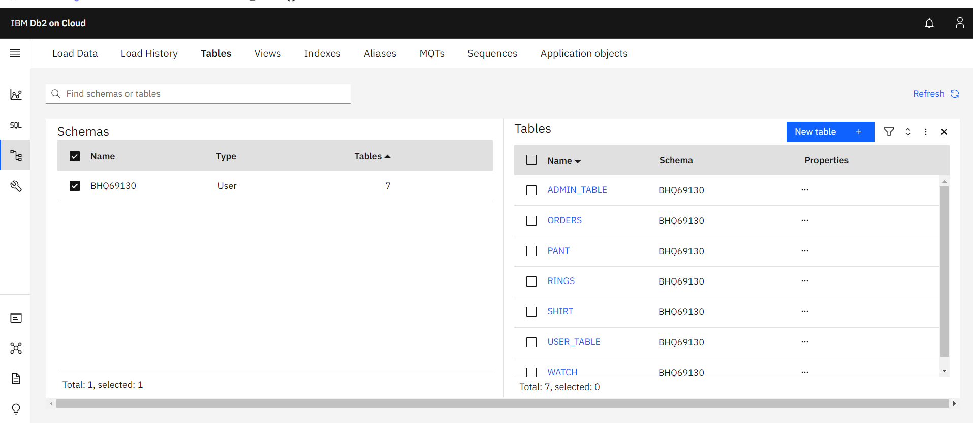

CONNECT WITH PYTHON

